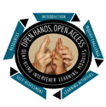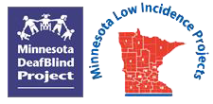

Spring 2023 Cohort for Teachers and Related Service Providers (T-9)
DeafBlind Learning Modules

Sponsored by the Minnesota Regional Low Incidence Projects and the Minnesota DeafBlind Project

Registration Link

Registration Deadline: Tuesday, January 3, 2023

Fee: $60.00 (Stipends available from Regional Low Incidence Facilitators (RLIFs). See registration link in myQuickReg for more information.)

Accommodations: OHOA modules are accessible including videos with closed captions, voice, and accessible print.

Target Audience: Licensed Educators and Related Service Providers serving Minnesota children and youth who are deafblind.

Program and Registration Questions: Ann Mayes 612-638-1527 | ann.mayes@metroecsu.org

Training Description: The Open Hands, Open Access (OHOA) DeafBlind Learning Modules are a national resource designed to increase awareness, knowledge, and skills related to supporting and teaching students who are deafblind and emergent communicators being served in educational settings (ages 3 – 21).
Guided coursework using four online modules of the training series:

Module 25 Importance of Touch
Module 6 Communication
Module 7 Emergent Communication
Module 8 Non-Symbolic Communication

The training includes:
- Hosted module format with engaging case studies, videos, slideshows, short readings, interactive group discussions and more.
- Learning from experts, teachers, interveners, individuals with deafblindness, and families.
- Distance coaching, course CEUs
- Only 1-2 hours per week are needed to complete the modules
(each module takes approximately 3 weeks to complete).

Facilitated by Carolyn Monaco: Carolyn has worked in the field of deafblindness for over 40 years. Her experience includes intervening, consulting, training and teaching in the Intervenor Program at George Brown College in Toronto, Canada. Carolyn has also been one of the key presenters in MN DeafBlind Project’s intervener weekend training series for many years. Her passion is assisting others to gain the skills and knowledge they need to improve the lives of those with deafblindness. She received an Anne Sullivan Macy Medal in 2018 for her outstanding work. When she isn’t working, Carolyn enjoys travelling, gardening and decorating her home.

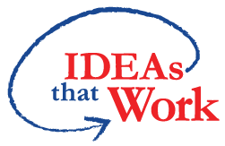Funding for this initiative is made possible with a grant from the MN Department of Education. The source of the funds is the federal award Special Education – Programs to States, CFDA 84.027A Special Education. And federal award – Project Title: Technical Assistance and Dissemination to Improve Services and Results for Children with Disabilities CFDA 84.326T of P.L. 108-446 Individuals with Disabilities Education Act.

